i
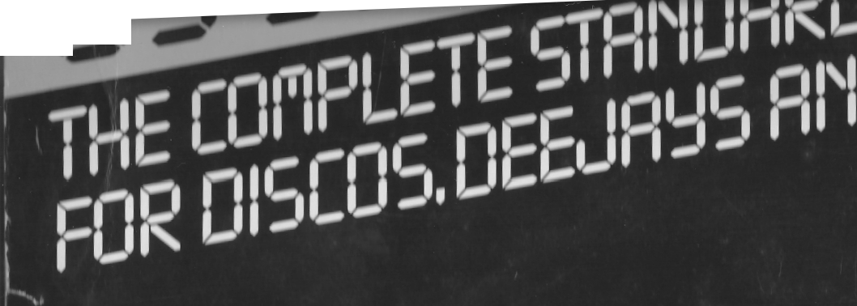
¹0
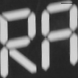
01
5
SIDE 1
1. A', lo n(1 0'. 11 ,'re's music , wall he 1hc wr e, I >Ic tying
the sc li r 1', lor you!
2. Music I l onl your h Tends! 3. We've (101 Ilse musice spirit! 4. 1 he music machine! 5. 1 he music eiaker•! 6. Nonstop music! 7. Nonstop music! (Acapella) 8. Nonstop music! (Whisper) 9. Were always on your side!
10. Disco Rock, Disco disco, Disco Rock! 11. Goodtime Rock & Roll! 12. Discodcincers do it on the floor!
13. Discodancers do it on in the mix!
14. Local Breakout!
15. And now..Jhis week's number one!
16. And now ...This week's number one! (Acapella)
17. Hit after hit after hit after hit! (Shout) 18. Top 10!
19. Top 10! (Acapella) 20. Top 20! 21. Top 20! (Acapella) 22. Top 30! 23. Top 30! (Acapella)
24. Io1, 40!
25. lolt 40! (Accrpell(i) 26. lop 50! 27. Top 50! (Acapella) 28. Good morning! 29. Good afternoon! 30. Good evening! 31. Good morning!
32. Good afternoon! SOFT-SHOUTS 33. Good evening!
34. Good morning! 35. Good afternoon! 36. Good evening!
37. Good night & sleep well!
38. Winterday, holiday, come with us and stay,
Merry Christmas!
39. Christmas swing (30 sec. filler + vocal
ending)
40. Auld lang Syne (30 sec. filler + vocal ending) 41. 30 sec. promotional musictrack A
instrumental
42. 30 sec. promotional musictrack B
instrumental
43. 30 sec, promotional musictrack C
instrumental
44. 30 sec. promotional musictrack D
instrumental
HARD-SHOUTS
SIDE 2
1
WHISPERS
WHISPERS
1. Golden oldie! (I illics sound)
2. Yesterday!
3. Super Gold!
4. The sound of 1960! 5. The sound of 61! 6. The sound of 62! 7. The sound of 63! 8. The sound of 64! 9. The sound of 65! 10. The sound of 66! 11. The sound of 67! 12. The sound of 68! 13. The sound of 69! 14. The sound of 1970! 15. The sound of 71 ! 16. The sound of 72! 17. The sound of 73! 18. The sound of 74! 19. The sound of 75! 20. The sound of 76! 21. The sound of 77! 22. The sound ol /8! 23. The sound oI /9! 24. The sound ol 1900!
2.'>. 11 r • n lr I (,1 1t 11
76. I I n t t t 1 .1 11'11
2/. I h, en.I „1 tial
')tt. 11 t -„,(li 1, 1, l 1341
29. Illr• tu1,1,r1 ti',I
30. 111r n n 1(1,)180
:31. I tt1 Ir u yl ar on1l nu,l :32. lei 1 in r 1 l r,w 33. Newsllosh! 34. Newsllc r.11 (Ar ril„dl(r) 35.Whr III 1 rr1rrrrll 36. W,r•kr ndd wr•rllhr•1I
3/. II c ilhc Newsl (Var (il 1 111 1111. 1 )

30 SEC. MUSICBEDS t VOCAL ENDINGS
38....(nnr,lc),..II'. 1111w _{y}„n kiu w, Iht, nl, r'st tn1
„I wlu li we (1, ~ t', Y't i 1 u 11 11'.'.1
40. ...(nlu'.u)...W "vr•.L.I sra tellap' Iru y 'u
t ll lyw'ry you 1(1(4 (11 u•.I
4 1 (nlu'.lr ) V,t''1,' 111,1111 ,411
our„ 111,1 01111
'ii,rwnull
Produced by: Ren Groot and Bart van Gogh
for Top Format Productions B.V.
P.O.B. 6040, 2001 HA HAARLEM. Tel. 023-320640/310522.
AII material protected under copyright.
Distributed by the Arlols Srsup of oom styles
Prlnrsd in Weter oormeny by MuhnllysA ell~llnll1 lUlr i allb~lt uiuIIItt imprllrllrn ipubilewe Nl~ltr 'Allele typ
Alli u rVO~_{lhl} IN n/y A eYnw~ +

