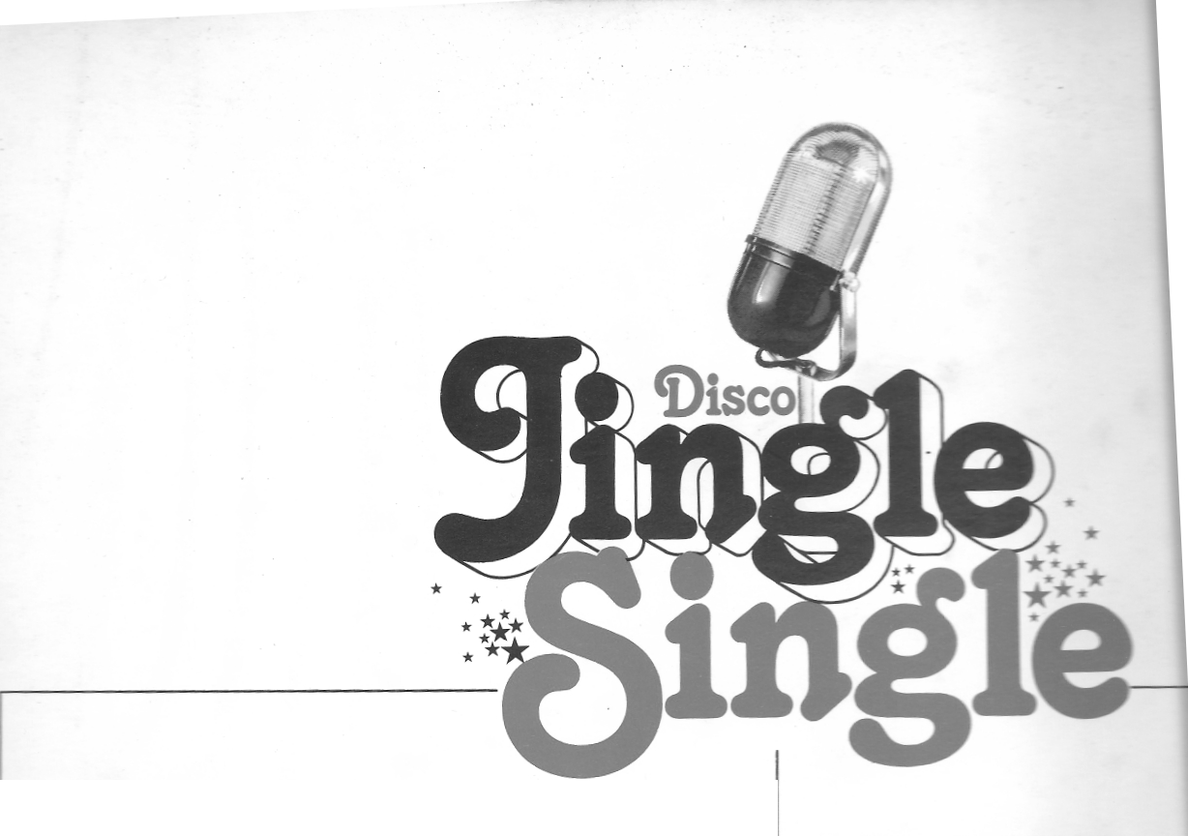
A-SIDE : VOCALS
1. | Disco Action! | 4 seconds
2. | Disco Action! | 4 seconds
3. | Radio Action,Radio Action! | 5 seconds
4. | Radio Action! | 3 seconds
5. | Disco Radio Action! | 7 seconds
6. | Disco Radio Action! | 4 seconds
7. | Gotta get the fever (disco filler) 32 seconds
8. | Disco fever(disco filler) 34 seconds
9. | Music Radio 11 seconds
10. Music Radio 5 seconds
11. The best music! 5 seconds
12. The best music on the best station! 6 seconds
13. Your music(soft) 5 seconds
14 ( fi[] in your name) .... Nobody does it better .... 11 seconds
15 (fill in your name) .... Nobody does it better .... 10 seconds
B-SIDE : INSTRUMENTALS
1. Intro t.^e
2. Special za= .
3. Hard roc< -~ . -- _ -_ _
4.
5.
6. R h ytm c a ^{witti} arp &brass - .
7. ,. ., ..
8.
9. Moog Percussion effect
10. .. ..
11
12
13. M oog i n formate on sagrwt urea _ . _ _ _ 13. .,
14. .. .. ..
15. Extro tune Iaresentation close-'
Produced by: Ren Groot for Top Format Prod
Broadcasting Consultants
Studio: Top 40, Hilversum.
Alle rechten: Top Format Productions B .V.
Parklaan 95, 2011 KS Haarlem TeL 023-320640/3105
~

