100
Offshore
Radio
Jingles
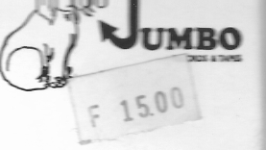
Jumbo Records & Tapes JR4
33/ RPM
