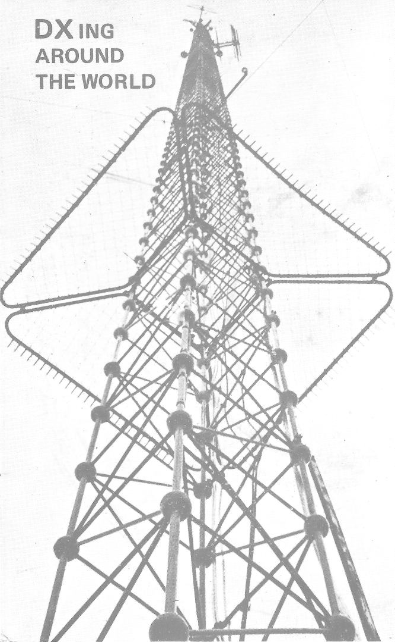
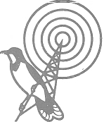
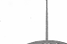
Ara
RADIO * P R A H A
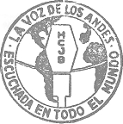
/a//B//C/
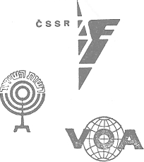
p10 BUDAP_{E}
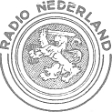
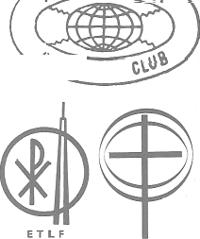
y0RT
WAVE
RÁDIC7 CLUEE DE MOCAMBiQUE
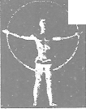
Monie Corlo Banave
RADIO MEC
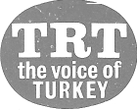

+SBC
DXING AROUND THE WORLD DXLP-1
SIDE A SIDE S
1. Trans World Radio (TWR), Netherlands Antilles ID in E, musical effects, IS, multilangual ID
2. Swiss Broadcasting Corporation (SBC), Switzerland ID in E, fanfare, time signal
3. Israel Broadcasting Authority, Israel IS, ID in E and Yiddish
4. Radio Canada (CBC), Canada IS, ID in French and English
5. Radio Nederland, Holland IS, opening music, ID in E
6. Voice of America (VOA), U.S.A.
IS, ID of Breakfast Show in E, electronic effects
7. La Voz de los Andes (HCJB), Ecuador ID in Spanish and English
8. Deutsche Welle (DW), Germany (West) Interval signal
9. Radio Sutatenza, Colombia
ID in Spanish, music, closing down ID, National Anthem
10. Radio Zambia, Zambia
Cries of the Zambian Fish Eagle, ID in Bemba and E
11. Radio Pakistan, Pakistan
Pakistani music, ID in English, music
12. Far East Broadcasting Company (FEBC), Philippines music, ID in English, music
13. Radio Budapest, Hungary
IS, opening music, ID in E, music, ID in E
14. American Forces Network (AFN), Germany (West) ID in English, interval signal
15. Rádio Alvorada da Londrina, Brazil Musical ID, spoken ID in Portuguese
Abbreviations used:
ID = station identification IS = interval signal E = English
1. Radio &Narsaw, Potend Interval signal
2. Radio Voice of the Gospel (ETLF), Ethiopia IS, ID in E, opening music, ID in E
3. Radio Ankara (TRT), Turkey IS, ID in Turkish and English
4. Radio Australia, Australia
"Waltzing Matilda", IS: the Kookaburra, ID in E, music
5. Radio Liberty, (Germany, Spain, Taiwan) IS, ID in Russian .
6. Radio Station ELWA, Liberia IS, ID in English
7. British Broadcasting Corporation (BBC), Great Britain Big Ben, ID in English
8. Trans World Radio (TWR), Monte Carlo, Monaco IS, ID in English
9. Radiodiffusion du Senegal, Senegal
African drumming, ID in French
10. Radio Thailand, Thailand Chimes, gongs, ID in Thai and E
11. Radio Vaticana, Vatican State Church bells, IS, ID in E
12. Radio Clube de Mozambique, Mozambique IS, ID in Portuguese, time signal, ID in E
13. Radio Prague, Czechoslovakia interval signal
14. Radio RSA, South Africa IS: the Bokmakierie, ID in E
15. Rádio Ministerio da Educacao e Cultura (Radio MEC), Brazil
ID in Portuguese, modern Brazilian music, ID in French and E
The copyrights of these recordings have been granted by the stations in question.
Finland's DX-Club International

P.O. Box 214, SF-00101 Helsinki 10, Finland
Finland's DX-Club International is a non-commercial, non-profit organization financed almost exclusively through fees paid by members. DX'ers living outside Finland are invited to join-fDXCI. The club publishes an offset bulletin, DXclusive, in English.

Suornen DX-Kuuntelijat ry.

Box 454, 00101 Helsinki 10, Finland
Valtakunnallinen DX-jar)estd Suomessa The biggest DX-club in Finland
Li3hempik tietoja monimuotoisesta DX-kuunteluharrasteesta saatte kirjoittamalla ylli3olevaan osoitteeseen.

