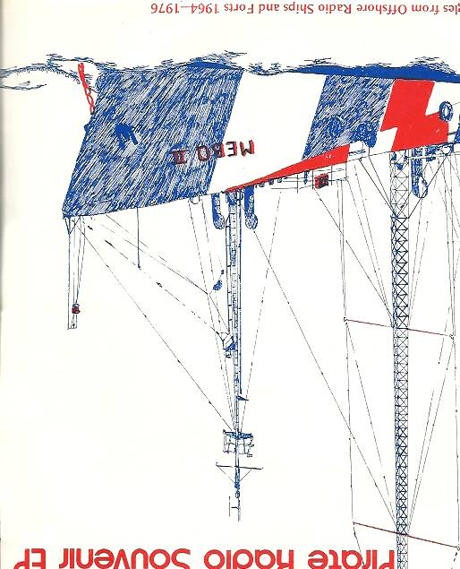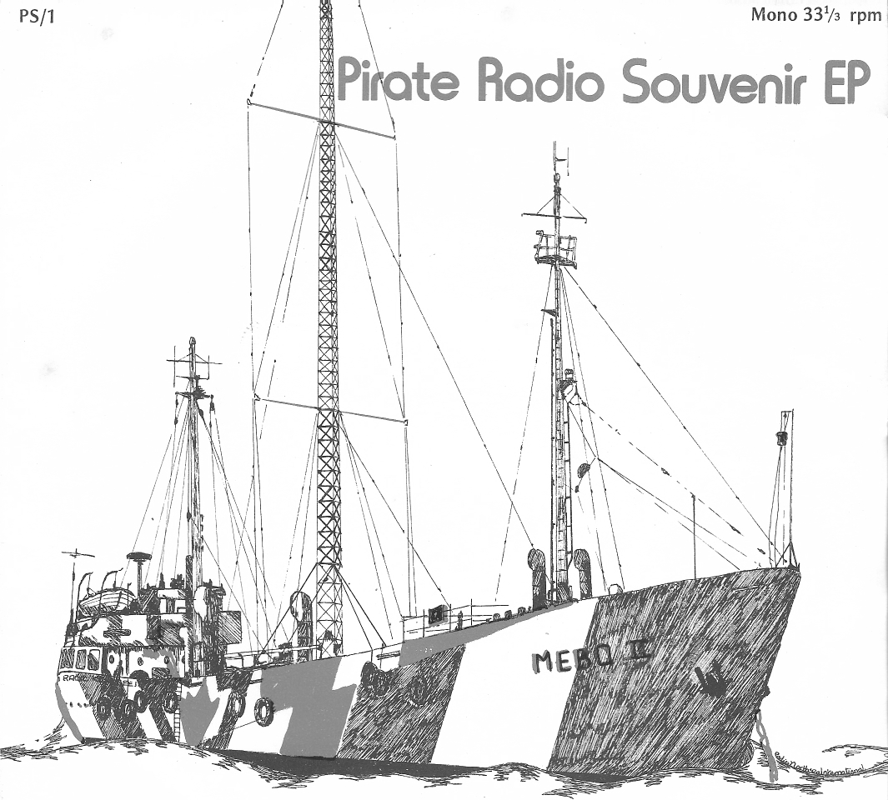

Jingles from Offshore Radio Ships and Forts 1964-1 976

This is number

Pirate Radio Souvenir EP

SIDE ONE
Caroline Bel]
Caroline - Sound of the nation Caroline - S 0 N, man that's groovy Sounds fine its Caroline C. A. R.O. L. I . N . E.

Caroline sure shot
You're hearing things on Wonderful Radio London We're gonna groove yeh ... W.R.L. The London Sound - Wonderful Music ... B.I.G.L. B.l.G.L.... Radio London We are listening to them ... Radio City
Radio City - Good morning to you from Radio City .. Yet get a positive charge, here on Tower of Power Radio City news on the hour On 242 metres this is Radio Scotland Fun for you on Radio Scotland 236 Big T, Big T, Radio Tower is a real cool show Halfmark of Quality ... Britain Radio Hall mark of Quality ... Britain Radio ... (long) Hallmark of Quality with music this that and the other Boss Radio - Swinging Radio England - out of sight! You get a positive ... CHARGE! Here, on swinging

Radio England
Swinging Radio England

It's Roger Day on Swinging Radio England Remember this golden classic ... swinging Radio
England
Veronica, Veronica
Going back in time on the sounds of the nation
Caroline Flash Back

News Beat presenting Caroline headline news and
weather
Now Radio London News tells you more, says it better Wonderful Radio London News around the clock Music London, Radio London - for your and me on

Big L
Go, Go, Go, Go, the Top 40 sound of Wonderful Radio London
Caroline International swingalong 654321 ONE ONE ONE
Arise and Shine with Caroline International the station with happy sounds
Wherever you go go with Caroline, Caroline go, go!
This is Radio Caroline International the home of the British Music Explosion The Radio A-Go, Go, Music

SIDE TWO

Veronica
Radio Vernoica
Come and rail away with Veronica to-day "Seagulls" - Radio Veronica News Radio Veronica, Radio Veronica ... Radio North Sea ... International
This is the happiest place Radio North Sea - the
happiest place

What good are friends if you never call on them, your
best friend station
R.N.I. Remember Travelling in to the years gone by

R.N.I.
This is the place that's going to blow your mind -

Radio North Sea
North Sea International
Radio Capitol ... This is Capitol Radio
Happy station, your happy station Radio Condor Radio Marina, 1 need you Marina Hello Radio Bennilux Hello Radio Atlantis set 'em off Atlantis here, Atlantis there, Atlantis everywhere Radio Atlantis - the station ahead of its time Radio Atlantis, Radio Atlantis, Radio Atlantis Atlantis here, there

Twiddly Dee, Teedly Dam this is the voice of peace
on 1540 kHz
Mi Amigo Radio, Mi Amigo Radio, here we go GO GO Mi Amigo Mi Amigo music all the way Radio Mi Amigo, Hey Mi Amigo, Hey Mi Amigo, Hey Radio, Radio Caroline
This is the new Radio Caroline
Flying to the sun sweet Caroline - Live from the
North Sea
A lot of good music Radio Caroline on 259
From a point in the sea to the circles in your mind Radio Caroline - more music!
Loving Awareness is a habit, a habit, Radio Caroline
L.A. is free
'br details of offshore radio books, records, posters and T-shirts, send a large sae to

Music Radio Promotions, PO Box 400, Kings Langley, Herts.

