Side 1
Contents
1 | 10,10,10,10 | 27 | Monday | 51
2 | 10, 9, 9, 9, 9 | 28 | Tuesday | 52
3 | 10,9,8,8,8,8 | 29 | Wednesday | 53
4 | 10, 9, 8, 7, 7, 7, 7 | 30 | Thursday | 54
5 | 10, 9, 8, 7, 6, 6, 6, 6 | 31 | Friday | 55
6 | 10,9,8,7,6,5,5,5,5 | 32 | Saturday | 56
7 | 10,9,8,7,6,5,4,4,4,4 | 33 | Sunday | 57
8 | 10, 9, 8, 7, 6, 5, 4, 3, 3, 3, 3 | 34 | Groovy | 58
9 | 10,9,8,7,6,5,4,3,2,2,2,2 | 35 | Funky soul - let's make it | 59
10 | 10,9,8,7,6,5,4,3,2,1,1,1,1 |  | funky | 60
11 | The top ten countdown | 36 | Back in the good old days | 61
12 | Let's all listen to the song | 37 | Smashback | 62
 | that's number 1 | 38 | Al] the hits and more and | 63
13 | Sweet, sweet, sweet - |  | more... | 64
 | soul music | 39 | Funky - wow yer it's | 65
14 | Music-with your favourite |  | funky - right on | 66
 | deejay | 40 | Music memories | 67
15 | Let's go back | 41 | Music memories, music | 68
16 | Ride on with much more |  | memories, music | 69
 | music |  | memories | 70
17 | Drive safely | 42 | S-O-U-L spells soul | 71
18 | Musical memories | 43 | Listen to the Music | 72
19 | It's funky | 44 | News Bulletin | 73
20 | Another hour of music | 45 | Music | 74
 | power | 46 | Flashback (repeat) | 75
21 | More music | 47 | Road report | 76
22 | Number 1 | 48 | Music memories. music | 77
23 | Listen to the music |  | memories, music | 78
24 | Music vibrations |  | memories | 79
25 | Off we go | 49 | Do you remember this? | 80
26 | And the beat goes on | 50 | Late night music | 81
 | (repeat) |  |  | 82

Let's go dart í~ tie
So-kd gold 1956 1957 1958 1959 1968 1961
1962 1963 1964 1965 1966 1967 1968 1969 1970 1971 1972 197'3 1974 1975
1976 :'7 i 1977
Good mo T i~g Good afternoon Good erenïg Great
Yesterday
This one's sold gold Mfe"re getting it taogell~er Neon-stop nusic

96 y ,r
99
SONOVOX VOICE: MOOG EFFECTS AND MUSIC:
RAY ANDERSON

RAY ANDERSON. CHRIS ANDERSON. ALAN WARRENDER RAY ANDERSON CHRIS ANDERSON RAY?NDERSON

LYRICS:
TECHNICAL ASSISTANT: STUDIO PRODUCTION: COVER DESIGN: PROL .; CE~



If Vak. ave e e- rear: Soar+} s Yac~rc ¢am . nme~-..c c e e 'ec -; s Deer aw tor -ra,y p
atxi⁻ _a--ars - _f₋ }_rc'.~ jr ⁻~.errtr„
Ar tast Aw~ Po+odrc~ ₃ -
.. e- r ra~ocs tam- P'5 .. aye araisaoc as IWM re E A 1rc e ?~ ` D' irr 1Si%C
Conte
27 r~ 20 Toy 25 MMGdn Mrc- , 30 Th~ 31 Friday 32 Sa~ 33 S~ 34 Groovy
35 Funky s~ -lets make it ko*y
37 ~ d old days 37
39 AO the hits and more and
more.. .
39 Fury - wow yer it's
funky - right on
40 w+sic memories
41 mernories. music
ruemories, music
non
42 S~ spells soul 43 Lesles to the Music 44- Mows Bulletin 45 Mc
46 Flash (_{re~)}
47 Road report
40 i m sones. mu wernories, music weeneories
49 Do you reme*nbe- tfus? 50 Laie night _ 5

51 | Leesgo ~* in
52 | Sobd gold
53 | 1956
54 | 1957
55 | 1958
56 | 1959
57 | 1960
58 | 1961
59 | 1962
60 | 1963
61 | 1964
62 | 1965
63 | 1966
64 | 1967
65 | 1968
66 | 1969
67 | 1970
68 | 1971
69 | 1972
:>e 2
70 1973
71 1974
72 1975
73 1976
74 1977
75 Good morning
76 Good afternoon 77 Good evening 78 Great 79 Yesterday
80 This one's solid gold
81 We're getting it together 82 Non-stop music
83 The marvellous music
machine
84 Non-stop music with the
marvellous music machine
85 Here's some more soul
music
86 It's funky
87 1 like it funky
88 Let's maké it funky
89 Funky
90 Wow yer it's funky
91 Mouldy oldie
92 Music
93 Music
94 Album time
95 Let's hear some more
music
96 Yesterday (repeat) 97 Listen to this
98 This one's number 1 99 S-O-U-L SOUL-thank
you very much
100 S-O-U-L SOUL
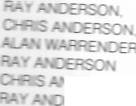
Z: Z
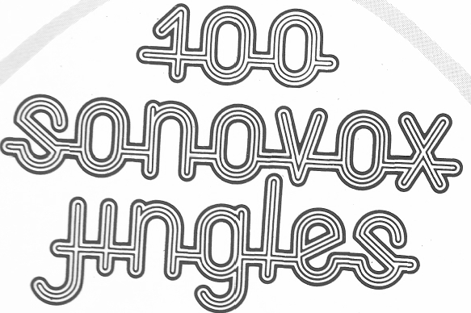
a °a d 'S parky's Magic Piano', then you have heard 'SONGVOX'. This
-as been used for many years, particularly on radio station id's. This
orox Jingles covering most deejay applications. East Anglian Production p & 9 ¹⁹⁷⁷ Made in Great Britain
ac`s 'o~ s LP are available on NAB loop and 8-track jingle cartridges. See e c=-- ₋.:e for further details.
